A PROJECT REPORT ON

**“A STUDY OF BUDGET AND BUDGETARY CONTROL” IN**

**WINGS 44 DESIGN AND MANUFACTURING PVT.LTD.**

**SHIROLI,KOLHAPUR**

SUBMITTED TO

**YASHWANTRAO CHAVAN MAHARASHTRA OPEN UNIVERSITY, NASHIK**

****

In Partial fulfillment of the requirement for the award of the degree of

**Master of Business Administration (MBA)**

SUBMITTED BY

**Miss. Amisha Suresh Nikam**

**PRN No.** : **2022017000160762**

UNDER THE GUIDANCE OF

**Prof. Dr. U. M. Deshmukh**

**(M.B.A Ph.D. FDPM(IIMA)M.Com.)**

THROUGH THE COORDINATOR

**VIVEKANAND COLLEGE, KOLHAPUR**

STUDY CENTRE CODE : 71122

**YEAR – 2023-24**

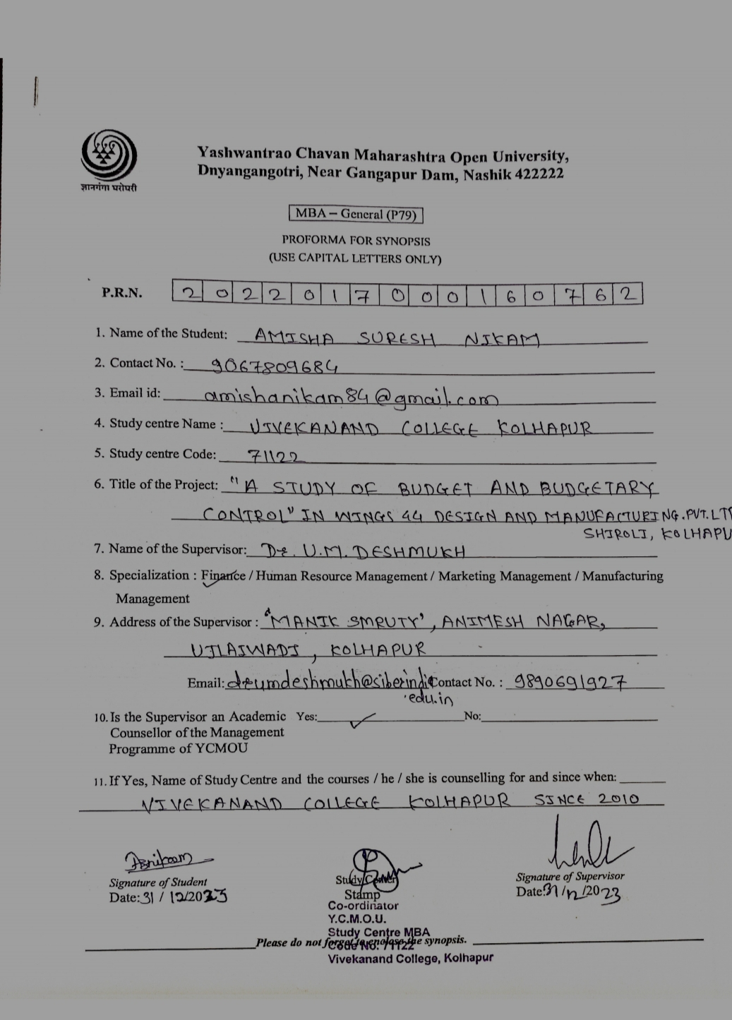

**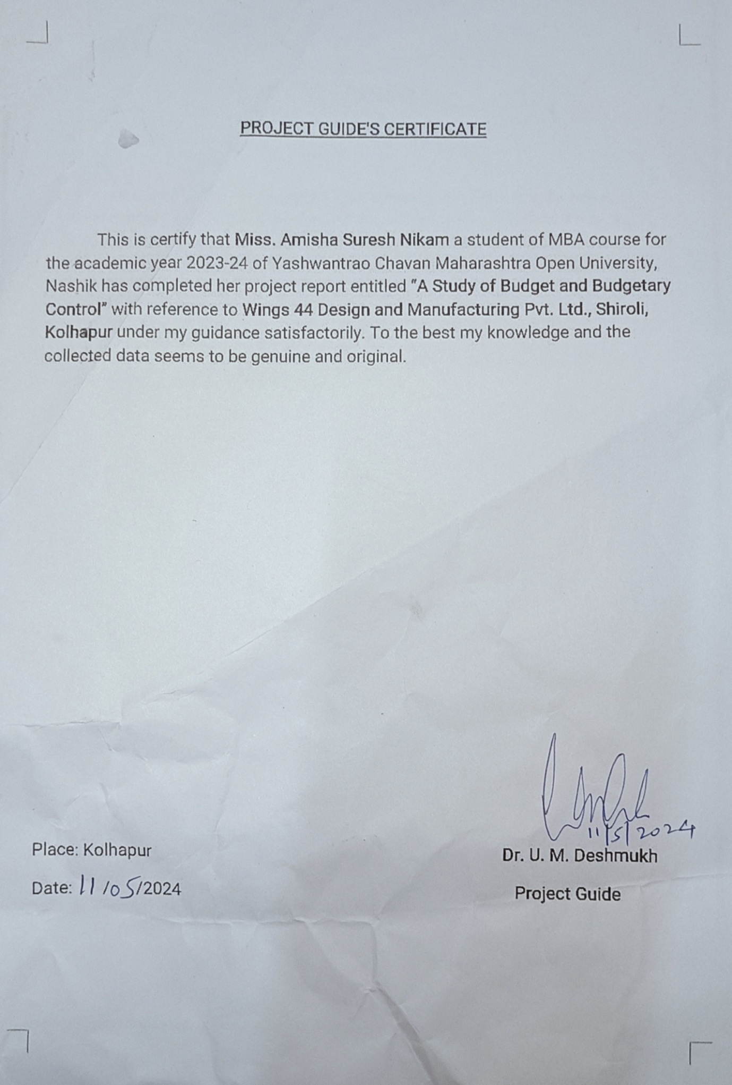**

**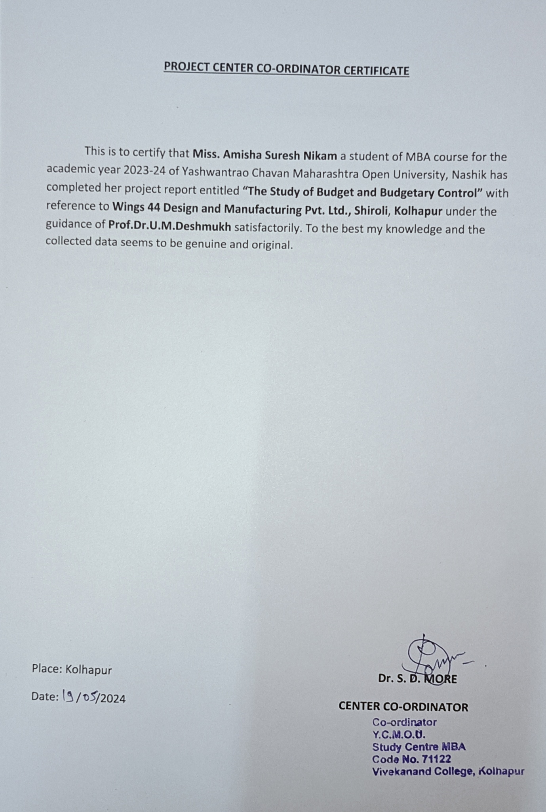**

****

****

****

**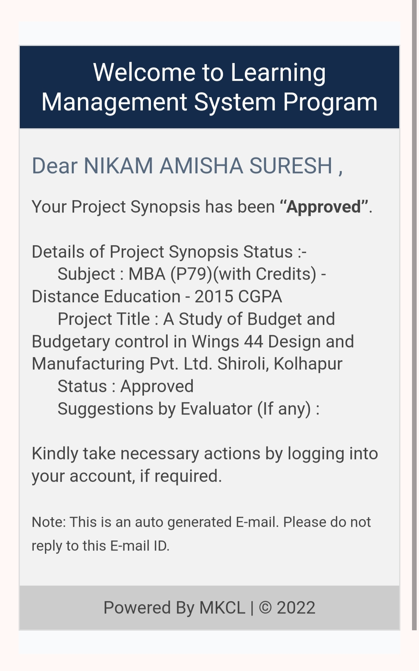**

A SYNOPSIS ON

**“A STUDY OF BUDGET AND BUDGETARY CONTROL” IN**

**WINGS 44 DESIGN AND MANUFACTURING PVT.LTD.**

**SHIROLI,KOLHAPUR**

SUBMITTED TO

**YASHWANTRAO CHAVAN MAHARASHTRA OPEN UNIVERSITY,**

**NASHIK**

****

In Partial fulfillment of the requirement for the award of the degree of

**Master of Business Administration (MBA)**

SUBMITTED BY

**Miss. Amisha Suresh Nikam**

**PRN No.** : **2022017000160762**

UNDER THE GUIDANCE OF

**Prof. Dr. U. M. Deshmukh**

**(M.B.A Ph.D. FDPM(IIMA)M.Com.)**

THROUGH THE COORDINATOR

**VIVEKANAND COLLEGE, KOLHAPUR**

STUDY CENTRE CODE : 71122

**YEAR – 2023-24**

**INTRODUCTION**

The life or death of any business enterprise depends upon the availability of cash. A Business firm/enterprise incurring losses still survive because of sufficiency of cash. Similarly, lack of cash can give rise to failure in the face of actual or prospective earnings. Budgetary control and standard costing systems are two essential tools frequently used by business executives for the purpose of cost planning and control. In the case of budgetary control, the entire exercise starts with the setting up of budgets or targets and ends with the taking of an action, in case the actual figures differ with the budgetary ones. The budget is one way to direct and coordinate business activities and units to achieve stated targets of performance. The budgetary units of an organization are called responsibility centers. Each responsibility center is led by a manager who has the authority over and responsibility for the unit’s performance.

Budget is essential in every walk of our life – national, domestic and Business. A budget is prepared to have effective utilization of funds and for the realization of objective as efficiently as possible. Budget and budgetary control provide a set of basic techniques for planning and control.

As the size of the organization increases, the need for budgeting is correspondingly more because a budget is an effective tool of planning and control. Budget is necessary to future to motivate the staff associated, to coordinate the activities of different departments and to control the performance of various persons operating at different levels.

**Importance of the Study :**

A budget helps create financial stability by tracking expenses and following a plan, a budget makes it easier to pay bills on time, build an emergency fund, and save for major expenses such as a car or home. A budget puts a person on stronger financial footing for both the day-to-day and the long term. It suggestions a set of conclusions in addition recommendations which be able to chief to the enrichment of the Budgeting control implemented by company. It helps in maximization of profits of the enterprise by proper planning and coordination of different functions.

**Review of Literature :**

1. **R.Shahana Parveen, S.Sathiya Naveena, S. Rathika** in their research article entitled as **“Budget and Budgetary Control”**explained that , Every organization needs Budget for smooth running of its activities. It serves as a link between inflow and outflow process of funds. The budget and budgetary control constitutes the most significant part for making profit by reducing expenditures. The purpose of budget and budgetary control is to compare actual with budgets and find the differences to have proper control over e very activity. The data used for the study is secondary data. The secondary data was collected through the journals, magazines, websites, company annual reports and other relevant records. The data was evaluated with the help of budgets like cash budget, sales budget, selling overhead budget and comparing budget with actual. The analytical research design has been used for the study. So, in order to understand the nature of budget and budgetary control of the organization, in this project analyzing different budgets techniques for maximize the profit.
2. **Lambe Issac, Mary Lawal , Theresa Okoli** in their research article entitled **as “A Systematic Review of Budgeting and Budgetary Control in Government Owned Organizations”**mentioned that, Budgeting and budgetary control entails the establishment of goals b the management of an organization and designing a process which serves as a framework within which an organization effectively articulates overall planned activities. The qualification of these planned activities in financial terms is known as budgeting , while the establishment of an effective mechanism to guarantee desired result is known as budgetary control. This study therefore seeks to undertake a systematic review of budgeting and budgetary control in Government owned organizations and given the importance of the foregoing, attention was focused on the Nigerian National petroleum Cooperation (NNPC). To achieve the objective of the study, primary data were obtained through the use of a well structured questionnaire administered to the respondents, while the secondary data were obtained from the annual financial statements, files, memos, tax laws and gazette of the NNPC. The findings revealed that a necessary and sufficient condition for achieving effective budgeting and budgetary control is the involvement of all relevant stakeholders in the preparation of the budget, is given the established processes in government circles, while emphasizing a deliberat3e and faithful implementation, by all responsible officers.
3. **Malyala Karthik , Shyam Sunder** in their research article entitled as **“A Study on Budgetary Control With Reference To HDFC Bank, Karimnagar”** explained that, No system of planning can be successful without having an effective and efficient system of control. Budgeting is closely connected with control. The exercise of control in the organization with the help of budgets is known as budgetary control. The process of budgetary control include: Preparation of various budgets Continuous comparison of actual performance with budgetary performance, Revision of budgets in the light of changed circumstances. A system of budgetary control should not become rigid. There should be enough scope of flexibility to provide for individual initiative and drive. Budgetary control is an important device for making the organization. More efficient on all fronts. It is an important tool for controlling costs an achieving the overall objectives.
4. **S.Sangeetha**, in their research article entitled **as “A Study on Budgeting and Budgetary Control with reference to supreme steel company”** explained that ,The financial data for a period five years of 2015 to 2019 Supreme steel analyzed for the study. The secondary data is used for the study and are collected from the annual reports of the company. The performance of the business was evaluated by analysis and interpreting the financial statement of the supreme steel with the help of ratio analysis, Trend analysis and comparative balance sheet. In this study try to address systematic issues related to budgeting and budgetary control.
5. **Santoshi Aru**, in their research article entitled as **“Purpose For Budgeting”** mentioned that, In the current economic climate, companies are starting to pay more attention to efficient management of resources and, for this purpose, use budgets as tools for financial management at company’s level and at the level of the main types of company’s activities. So, the budget is the most important tool in conducting any activity successfully. A budget is the tool by which a company’s management translates into action the corporate strategies and quantitative mission statements.
6. **Ifrah Ahmed Mohamed**,in their article entitled **as “Analysis of the Effectiveness of Budgetay Control Techniques on Organizational Performance at Dara-Salaam Bank headquarters in Hargeisa Somaliland”**, this study explained how budgetary control can impact on the performance of Dara-Salaam Bank. The objectives were to find out how responsibility accounting influences organizational performance, to determine whether variance cost analysis affects organizational performance and to establish how zero based budgeting affects theory. Empirical literature was guided by the objectives. The study utilized descriptive and retrospective research designs. Both primary and secondary data were used. Primary data was collected by use of questioners, while secondary data was collected from published materials. The researcher carried out a census study of the 70 staff of Dara-salaam Bank in Hargeisa Somaliland. Ethical considerations of this study were ensured confidentiality on the part of respondents and to set clear researchers purpose to all respondents. Data entered into excel was presented by the use of frequency tables.

The study recommends further research on budget planning and organizational performance and also the relationship between budget implementation and organizational performance.

1. **Manoj Kumar Chaudhary, Rajesh Kumar Chaudhary**, in their article entitled as **“Budgetary Control and Financial Performance of Nepal Oil Corporation”**, the main purpose of this paper is to examine the relationship between budgetary control and financial performance of Nepal Oil Corporation (NOC) while presenting the real scenario of the organization. Therefore, to test the practice of budgetary control and financial performance, a descriptive survey design, as a sample of the study, was used to gather data through structured questionnaire distributed to 60 respondents from Account, Finance, Administration, Engineering and Project Department. The findings of this study emphasize that a practice of budgetary control leads to increased profitability but for that management commitment is indispensable. The study concludes that budgetary control process shows a significant positive bearing on the financial performance of NOC through the influences on financial objectives, allocation of funds as well as investment ventures. The study recommends a sensitization of management and employees of NOC along the lines of the importance of budgetary controls in enhancing financial performance, avoidance of unnecessary interference in the budgetary process and use of budgets as tools for management efficiency.
2. **Prof. Mubina Shaikh**, in their research article entitled as **“A Study on Budget and Budgetary Control”** explained that, Budgetary control is a system in which income and spending are compared with a company’s to make sure the plans are being followed. It allows companies to adjust their spending as necessary to make a profit. Every company has a budget, and at times, that budget needs to be revised to account for spending and an increase or decrease in income. In essence, budgetary control compares actual results with budgets. If discrepancies are found, key players within a company have two choices. They can either control the spending of the company or revise the original budgets. Budgetary control helps to coordinate and organize a company’s financial activities. The study of budgetary control is very helpful for management of companies for control of their expenditure through a powerful instrument that the name is budget. In fact it will provide a yardstick for measuring and evaluating the performance of individuals and their departments.
3. **Dr. K. Manoharan Nair, Alireza Kaab**, in their research article entitled as **“Budgeting and Budgetary Control System: A study on Selected Indian Companies”** explained that, Budgeting is very important and it determines the way in which the organization can attain its financial and other goals. It is an estimate about the future actions of the management in the form of financial statements. Once the budget is set in quantitative or qualitative terms the management try their best for not exceeding the target set. But an account of dynamic nature of the environment both internal and external the estimated figure will vary. As a control measure they traise for the variations between the actual and the budgeted one and identify the causes of such variations and take corrective measures for not occurring such variations in future. One of the components which is significant for internal control system is budgetary control system(BCS). The objective of the present study is to know the budgetary control system in selected Indian companies.
4. **Oluwadare Joshua OYEBODE**, in their research article entitled as **“ Budget and Budgetary control : A Pragmatic Approach to the Nigerian Infrastructure Dilemma”** explained that, Planning involves developing objectives for the construction management, infrastructure development and preparation of various budgets to achieve desired objectives to avoid cost overrun and time extensions. This study evaluates the impact of budgeting and budgetary control on the performance of manufacturing company in Nigeria with an approach to Nigerian Engineering Infrastructure. This was conducted using Cadbury Nigeria Plc., as case study. Since wants are plenty while resources are limited, every organization tends to find means by which it can get what it wants with the limited resources at its disposal. Therefore, firms seek to adopt the concept of budgeting and budgetary control in satisfy their needs at the least possible cost and at the same time fulfill their stewardship obligations to the numerous stakeholders. We adopted a descriptive research design with data gathered through questionnaire administered to respondents. Non-parametric tool of chi square was employed to analyze the data. Hypothesis were tested and analyzed on a 5% level of significance and it was revealed that budgeting is a useful tool that guides firms to evaluate whether their goals and objectives are actualized. Considering the changing environment in which continuous management activity, should adapt to changes in the dynamic business environment in order to avoid infrastructural dilemma.

**Objectives of the Study :**

1. understand the budget and budgetary control system of Wings 44.
2. To study variations of components of revenue budget and components of operational expenditure budget.
3. To analyze and compare the variation of revenue budget and operational budget.
4. To suggest the effective budgetary mechanism for Wings 44.

**Hypothesis of the Study :**

1. The implementation of budgetary control significantly influences the financial performance of Wings 44 Company.
2. The budgeting process at Wings 44 Company significantly contributes to cost efficiency.

**Scope of the Study :**

The project is helpful to define the business objectives precisely and establish

the performance targets. The project is helpful to delineate the responsibilities

of each department as well as each person. The project is helpful to create a

standard benchmark for measuring for measuring performance

**Research Methodology :**

The data will be collected with the help of both primary and secondary sources of data collection.

**Primary Data :**

The primary data will be collected by interacting with the finance assistant, manager of the company.

**Secondary Data :**

1. The secondary data used for the study will be e3xtracted from the annual reports, manuals, accounting books, records and other published material of the company.

**Limitations :**

Estimates will be used as basis for budget plan and estimates are based

mostly on available facts and best managerial judgment. Budgetary

control cannot reduce the managerial function to a formula.

**Expected Contribution :**

1. Suggest potential improvements or modifications to the budgetary process based on your analysis and research findings.
2. Explore different budgeting techniques utilized by Wings 44 company, comparing traditional methods like incremental budgeting with modern approaches such as zero-based budgeting.
3. Evaluate the effectiveness of Wings 44’s budgetary control systems in managing costs, identifying variances, and taking corrective actions.
4. Analyze the impact of budgeting on the company’s financial performance. Investigate how closely the actual performance aligns with the budgeted figures.

**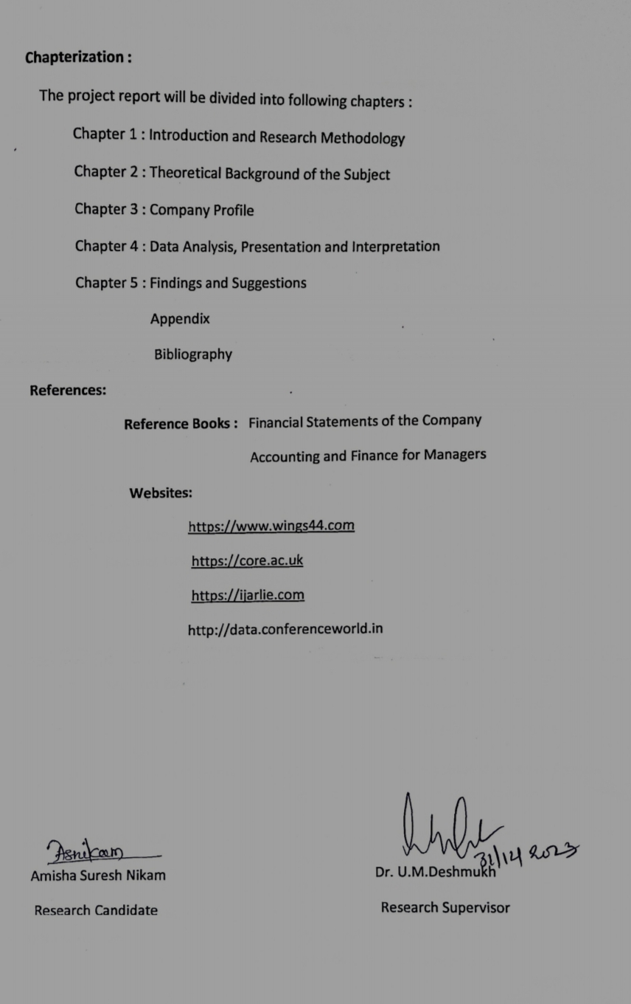**

**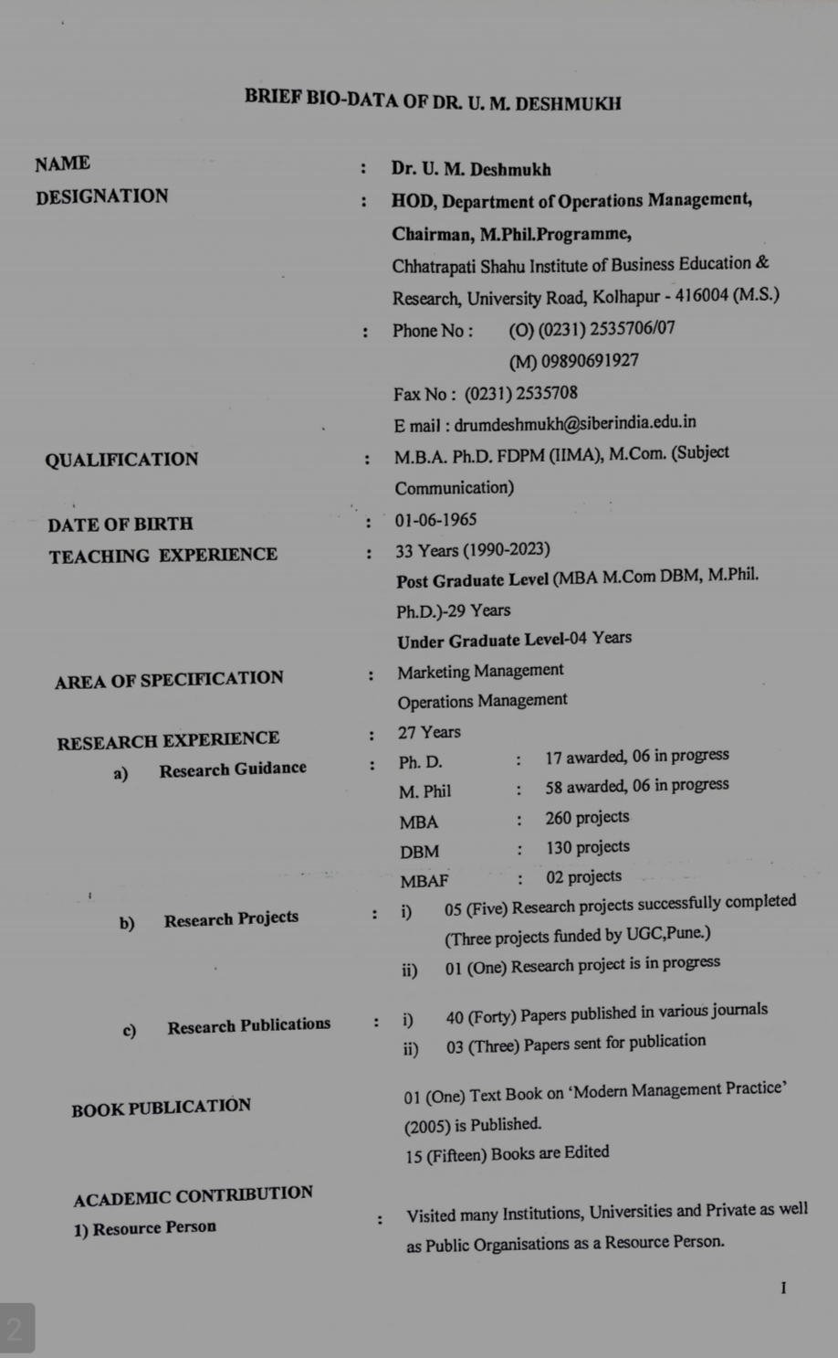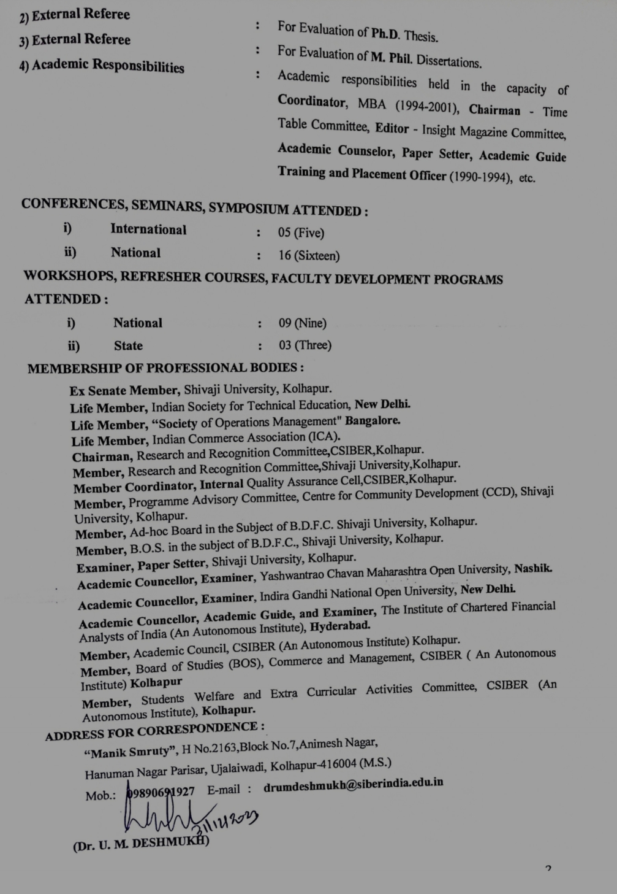**

**INDEX**

|  |  |  |
| --- | --- | --- |
| Sr.No. | Particulars | Page |
| 1. | Chapter -1 : Introduction and Research Methodology | 21-30 |
| 2. | Chapter – 2 : Theoretical Background of the Subject | 31-46 |
| 3. | Chapter – 3 : Company Profile | 47-53 |
| 4. | Chapter – 4 : Data Analysis, Presentation and Interpretation | 54-60 |
| 5. | Chapter – 5 : Findings and Suggestions | 61-64 |
|  | Appendix and Bibliography | 65 |

**CHAPTER – 1 :**

**INTRODUCTION OF THE SUBJECT**

**INTRODUCTION**

Budget is essential in every walk of our life – national, domestic and Business. A

budget is prepared to have effective utilization of funds and for the realization of objective as

efficiently as possible. Budgeting is a powerful tool to the management for performing its

functions i.e., formulation plans, coordination activities and controlling operations etc.,

efficiently. For efficient and effective management planning and control are tow highly

essential functions. Budget and budgetary control provide a set of basic techniques for

planning and control.

A budget fixes a target in terms of rupees or quantities against which the actual

performance is measured. A budget is closely related to both the management function as well

as the accounting function of an organization. As the size of the organization increases, the

need for budgeting is correspondingly more because a budget is an effective tool of planning

and control. Budget is helpful in coordinating the various activities (such as production, sales,

purchase etc) of the organization with result that all the activities precede according to the

objective.

Budgets are means of communication. Ideas of the top management are given the

practical shape. As the activities of various department heads are coordinated at the much

needed for the very success of an organization. Budget is necessary to future to motivate the

staff associated, to coordinate the activities of different departments and to control the

performance of various persons operating at different levels. Budgets may be divided into two basic classes. Capital and operating budgets. Capital budget are directed towards proposed expenditure for new projects and often require special financing. The operating budgets are directed towards achieving short-term operational goals of the organization for instance, production or profit goals in a business firm. Operating budgets may be sub-divided into various departmental of functional budgets. This system helps in fixing the goals for the organization as a whole and concentrated efforts are made for its achievements. No system of planning can be successful without having an effective and efficient system of control. Budgeting is closely connected with control. The exercise of control in the organization with the help of budgets is known as budgetary control.

The process of budgetary control includes:

1. Preparation of various budgets.

2. Continuous comparison of actual performance with budgetary performance.

3. Revision of budgets in the light of changed circumstances.

A system of budgetary control should not become rigid. There should be enough scope of

flexibility to provide for individual initiative and drive. Budgetary control is an important

device for making the organization. More efficient on all fronts. It is an important tool for

controlling costs and achieving the overall objectives.

Some advantages of budget and budgetary system are:

a) It helps in maximization of profits of the enterprise by proper planning and

coordination of different functions.

b) The working of different departments and sectors is properly coordinated to achieve the

target of the budget.

c) The deviation in budgeted and actual performance will enable the determination of

weak spots

d) The management will be able to take corrective measures whenever there is a

discrepancy in performance.

Controlling your financial affairs requires a budget. For many people, the word "budget" has a negative connotation. Instead of thinking of a budget as financial handcuffs, think of it as a means to achieve financial success.

Whether you make thousands of naira a year or hundreds of thousands of naira a year, a budget is the first and most important step you can take towards putting your money to work for you instead of being controlled by it and forever falling short of your financial goals.

Budgeting and tracking your expenses gives you a strong sense of where your money goes and

can help you reach your financial goals. Since financial matters are one of the leading causes

of marital discord and divorce, getting a handle on your spending, implementing a budget, and

saving for the future can also have positive effects on your relationship with your spouse or

partner.

**Review of Literature :**

1. **R.Shahana Parveen, S.Sathiya Naveena, S. Rathika** in their research article entitled as **“Budget and Budgetary Control”**explained that , Every organization needs Budget for smooth running of its activities. It serves as a link between inflow and outflow process of funds. The budget and budgetary control constitutes the most significant part for making profit by reducing expenditures. The purpose of budget and budgetary control is to compare actual with budgets and find the differences to have proper control over e very activity. The data used for the study is secondary data. The secondary data was collected through the journals, magazines, websites, company annual reports and other relevant records. The data was evaluated with the help of budgets like cash budget, sales budget, selling overhead budget and comparing budget with actual. The analytical research design has been used for the study. So, in order to understand the nature of budget and budgetary control of the organization, in this project analyzing different budgets techniques for maximize the profit.
2. **Lambe Issac, Mary Lawal , Theresa Okoli** in their research article entitled **as “A Systematic Review of Budgeting and Budgetary Control in Government Owned Organizations”**mentioned that, Budgeting and budgetary control entails the establishment of goals b the management of an organization and designing a process which serves as a framework within which an organization effectively articulates overall planned activities. The qualification of these planned activities in financial terms is known as budgeting , while the establishment of an effective mechanism to guarantee desired result is known as budgetary control. This study therefore seeks to undertake a systematic review of budgeting and budgetary control in Government owned organizations and given the importance of the foregoing, attention was focused on the Nigerian National petroleum Cooperation (NNPC). To achieve the objective of the study, primary data were obtained through the use of a well structured questionnaire administered to the respondents, while the secondary data were obtained from the annual financial statements, files, memos, tax laws and gazette of the NNPC. The findings revealed that a necessary and sufficient condition for achieving effective budgeting and budgetary control is the involvement of all relevant stakeholders in the preparation of the budget, is given the established processes in government circles, while emphasizing a deliberat3e and faithful implementation, by all responsible officers.
3. **Malyala Karthik , Shyam Sunder** in their research article entitled as **“A Study on Budgetary Control With Reference To HDFC Bank, Karimnagar”** explained that, No system of planning can be successful without having an effective and efficient system of control. Budgeting is closely connected with control. The exercise of control in the organization with the help of budgets is known as budgetary control. The process of budgetary control include: Preparation of various budgets Continuous comparison of actual performance with budgetary performance, Revision of budgets in the light of changed circumstances. A system of budgetary control should not become rigid. There should be enough scope of flexibility to provide for individual initiative and drive. Budgetary control is an important device for making the organization. More efficient on all fronts. It is an important tool for controlling costs an achieving the overall objectives.
4. **S.Sangeetha**, in their research article entitled **as “A Study on Budgeting and Budgetary Control with reference to supreme steel company”** explained that ,The financial data for a period five years of 2015 to 2019 Supreme steel analyzed for the study. The secondary data is used for the study and are collected from the annual reports of the company. The performance of the business was evaluated by analysis and interpreting the financial statement of the supreme steel with the help of ratio analysis, Trend analysis and comparative balance sheet. In this study try to address systematic issues related to budgeting and budgetary control.
5. **Santoshi Aru**, in their research article entitled as **“Purpose For Budgeting”** mentioned that, In the current economic climate, companies are starting to pay more attention to efficient management of resources and, for this purpose, use budgets as tools for financial management at company’s level and at the level of the main types of company’s activities. So, the budget is the most important tool in conducting any activity successfully. A budget is the tool by which a company’s management translates into action the corporate strategies and quantitative mission statements.
6. **Ifrah Ahmed Mohamed**,in their article entitled **as “Analysis of the Effectiveness of Budgetay Control Techniques on Organizational Performance at Dara-Salaam Bank headquarters in Hargeisa Somaliland”**, this study explained how budgetary control can impact on the performance of Dara-Salaam Bank. The objectives were to find out how responsibility accounting influences organizational performance, to determine whether variance cost analysis affects organizational performance and to establish how zero based budgeting affects theory. Empirical literature was guided by the objectives. The study utilized descriptive and retrospective research designs. Both primary and secondary data were used. Primary data was collected by use of questioners, while secondary data was collected from published materials. The researcher carried out a census study of the 70 staff of Dara-salaam Bank in Hargeisa Somaliland. Ethical considerations of this study were ensured confidentiality on the part of respondents and to set clear researchers purpose to all respondents. Data entered into excel was presented by the use of frequency tables.

The study recommends further research on budget planning and organizational performance and also the relationship between budget implementation and organizational performance.

1. **Manoj Kumar Chaudhary, Rajesh Kumar Chaudhary**, in their article entitled as **“Budgetary Control and Financial Performance of Nepal Oil Corporation”**, the main purpose of this paper is to examine the relationship between budgetary control and financial performance of Nepal Oil Corporation (NOC) while presenting the real scenario of the organization. Therefore, to test the practice of budgetary control and financial performance, a descriptive survey design, as a sample of the study, was used to gather data through structured questionnaire distributed to 60 respondents from Account, Finance, Administration, Engineering and Project Department. The findings of this study emphasize that a practice of budgetary control leads to increased profitability but for that management commitment is indispensable. The study concludes that budgetary control process shows a significant positive bearing on the financial performance of NOC through the influences on financial objectives, allocation of funds as well as investment ventures. The study recommends a sensitization of management and employees of NOC along the lines of the importance of budgetary controls in enhancing financial performance, avoidance of unnecessary interference in the budgetary process and use of budgets as tools for management efficiency.
2. **Prof. Mubina Shaikh**, in their research article entitled as **“A Study on Budget and Budgetary Control”** explained that, Budgetary control is a system in which income and spending are compared with a company’s to make sure the plans are being followed. It allows companies to adjust their spending as necessary to make a profit. Every company has a budget, and at times, that budget needs to be revised to account for spending and an increase or decrease in income. In essence, budgetary control compares actual results with budgets. If discrepancies are found, key players within a company have two choices. They can either control the spending of the company or revise the original budgets. Budgetary control helps to coordinate and organize a company’s financial activities. The study of budgetary control is very helpful for management of companies for control of their expenditure through a powerful instrument that the name is budget. In fact it will provide a yardstick for measuring and evaluating the performance of individuals and their departments.
3. **Dr. K. Manoharan Nair, Alireza Kaab**, in their research article entitled as **“Budgeting and Budgetary Control System: A study on Selected Indian Companies”** explained that, Budgeting is very important and it determines the way in which the organization can attain its financial and other goals. It is an estimate about the future actions of the management in the form of financial statements. Once the budget is set in quantitative or qualitative terms the management try their best for not exceeding the target set. But an account of dynamic nature of the environment both internal and external the estimated figure will vary. As a control measure they traise for the variations between the actual and the budgeted one and identify the causes of such variations and take corrective measures for not occurring such variations in future. One of the components which is significant for internal control system is budgetary control system(BCS). The objective of the present study is to know the budgetary control system in selected Indian companies.
4. **Oluwadare Joshua OYEBODE**, in their research article entitled as **“ Budget and Budgetary control : A Pragmatic Approach to the Nigerian Infrastructure Dilemma”** explained that, Planning involves developing objectives for the construction management, infrastructure development and preparation of various budgets to achieve desired objectives to avoid cost overrun and time extensions. This study evaluates the impact of budgeting and budgetary control on the performance of manufacturing company in Nigeria with an approach to Nigerian Engineering Infrastructure. This was conducted using Cadbury Nigeria Plc., as case study. Since wants are plenty while resources are limited, every organization tends to find means by which it can get what it wants with the limited resources at its disposal. Therefore, firms seek to adopt the concept of budgeting and budgetary control in satisfy their needs at the least possible cost and at the same time fulfill their stewardship obligations to the numerous stakeholders. We adopted a descriptive research design with data gathered through questionnaire administered to respondents. Non-parametric tool of chi square was employed to analyze the data. Hypothesis were tested and analyzed on a 5% level of significance and it was revealed that budgeting is a useful tool that guides firms to evaluate whether their goals and objectives are actualized. Considering the changing environment in which continuous management activity, should adapt to changes in the dynamic business environment in order to avoid infrastructural dilemma.

**OBJECTIVES OF STUDY**

1. To understand the budget and budgetary control system of Wings 44.
2. To study variations of components of revenue budget and components of operational expenditure budget.
3. To analyze and compare the variation of revenue budget and operational budget.
4. To suggest the effective budgetary mechanism for Wings 44.

**HYPOTHESIS OF THE STUDY**

1. The implementation of budgetary control significantly influences the financial performance of Wings 44 Company.
2. The budgeting process at Wings 44 Company significantly contributes to cost efficiency.

**NEED AND IMPORTANCE OF BUDGET AND BUDGETARY CONTROL**

Budgetary control is a strong tool of business is to maximize profits. The management is therefore always trying to focus on the proper planning, effective coordination and control in order to maximize profits. There are various managerial tools and techniques useful for the management to plan and control business operations. Budget is also used for the management to plan and control business operations and it is widely used as a standard device of planning and control.

Budget provides as a valuable aid to management through planning, coordination

and control. It is a tool which measures the managerial performance of an organization. It

promotes good morale and generates harmony in the organization. Also it promotes efficiency

and facilities management by exceptions. It helps in promoting a feeling of cost consciousness

among the employees in the organization.

On the other side, as a budget is based on estimates, it may or may not be true. It is

not substitute of management because, the efficiency and utility of the budgetary system

depends on the skill and experience of the management. It cannot be executed automatically

because continuous efforts are necessary for the execution of the budget. In case of the

manufacturing organizations, the estimation about the future is very important for the

production activities as huge amount of costs are invested in the same activity.

**LIMITATIONS:**

1.Estimates are used as basis for budget plan and estimates are based mostly on available

facts and best managerial judgment

2.Budgetary control cannot reduce the managerial function to a formula. It is only a

managerial.

3.Tool which increase effectiveness of managerial control.

4.The use of budget may be to restricted use of resources. Budgets an often taken as

limits.

5.The study is the limited up to the date and information provided by Wings 44 Design and Manufacturing Pvt.Ltd and its annual reports.

**SCOPE OF THE STUDY:**

Since it is not possible to conduct macro level study of all software industries , so this study is restricted to Wings 44 only.

The study is limited based on data provided by the company’s financial statements. So the

limitations of the statements are equally applicable of this study.

The study is limited for a period of 3 years i.e., from 2020-2023.

**RESEARCH METHODOLOGY:**

The proposed study is carried with the help of both primary and secondary sources of data.

**PRIMARY DATA:**

The primary data is collected by interacting with the finance manager and other concerned

executives at the administrative office of the company.

**SECONDARY DATA:**

All the secondary data used for the study has been extracted from the annual reports, manuals

and other published material of the company.

**SOURCES OF DATA:**

The data of Wings 44 Design and Manufacturing Pvt.Ltd. , have been collected mainly from

secondary sources viz.

1. Form the concerned employees of the Wings 44 Pvt. Ltd

2. Wings 44 Design and Manufacturing Pvt.Ltd. journals.

3. Accounting books, records.

4. Key books of concerned title.

5. Statistical records

**Chapterization :**

The project report is divided into following chapters :

Chapter 1 : Introduction and Research Methodology

Chapter 2 : Theoretical Background of the Subject

Chapter 3 : Company Profile

Chapter 4 : Data Analysis, Presentation and Interpretation

Chapter 5 : Findings and Suggestions

Appendix

Bibliography

**CHAPTER – 2 :**

**THEORETICAL BACKGROUND OF THE SUBJECT**

**THEORETICAL BACKGROUND OF THE SUBJECT**

**Meaning and Definition:**

Budget: According to CIMA (Chartered Institute of Management Accountants) UK, a budget is “A plan quantified in monetary terms prepared and approved prior to a defined period of time, usually showing planned income to be generated and, expenditure to be incurred during the period and the capital to be employed to attain a given objective.”

In a view of Keller & Ferrara, “a budget is a plan of action to achieve stated objectives based on predetermined series of related assumptions.” G.A.Welsh states, “A budget is a written plan covering projected activities of a firm for a definite time period.”

One can elicit the explicit characteristics of budget after observing the above definitions. They are…

* It is mainly a forecasting and controlling device.

• It is prepared in advance before the actual operation of the company or project.

* It is in connection with definite future period.
* Before implementation, it is to be approved by the management.
* It also shows capital to be employed during the period.

**Budgetary Control:**

Budgetary Control is a method of managing costs through preparation of budgets. Budgeting is thus only a part of the budgetary control. According to CIMA, “Budgetary control is the establishment of budgets relating to the responsibilities of executives of a policy and the continuous comparison of the actual with the budgeted results, either to secure by individual action, the objective of the policy or to provide a basis for its revision.”

The main features of budgetary control are:

1. Establishment of budgets for each purpose of the business.

2. Revision of budget in view of changes in conditions.

3. Comparison of actual performances with the budget on a continuous basis.

4.. Analysis of variations of actual performance from that of the budgeted performance to know the reasons thereof.

**Objectives of Budgetary Control:**

Budgeting is a forward planning. It serves basically as a tool for management control; it is rather a pivot of any effective scheme of control.

The objectives of budgeting may be summarized as follows:

**1. Planning:** Planning has been defined as the design of a desired future position for an entity and it rests on the belief that the future position can be attained by uninterrupted management action. Detailed plans relating to production, sales, raw‐material requirements, labour needs, capital additions, etc. are drawn out. By planning many problems estimated long before they arise and solution can be thought of through careful study. In short, budgeting forces the management to think ahead, to foresee and prepare for the anticipated conditions. Planning is a constant process since it requires constant revision with changing conditions.

**2. Co‐ordination:** Budgeting plays a significant role in establishing and maintaining coordination. Budgeting assists managers in coordinating their efforts so that problems of the business are solved in harmony with the objectives of its divisions. Efficient planning and business contribute a lot in achieving the targets. Lack of co‐ordination in an organization is observed when a department head is permitted to enlarge the department on the specific needs of that department only, although such development may negatively affect other departments and alter their performances. Thus, co‐ordination is required at all vertical as well as horizontal levels.

**3. Measurement of Success:** Budgets present a useful means of informing managers how well they are performing in meeting targets they have previously helped to set. In many companies, there is a practice of rewarding employees on the basis of their accomplished low budget targets or promotion of a manager is linked to his budget success record. Success is determined by comparing the past performance with previous period's performance.

**4. Motivation:** Budget is always considered a useful tool for encouraging managers to complete things in line with the business objectives. If individuals have intensely participated in the preparation of budgets, it acts as a strong motivating force to achieve the goals.

**5. Communication:** A budget serves as a means of communicating information within a firm. The standard budget copies are distributed to all management people provide not only sufficient understanding and knowledge of the programmes and guidelines to be followed but also give knowledge about the restrictions to be adhered to.

**6. Control:** Control is essential to make sure that plans and objectives laid down in the budget are being achieved. Control, when applied to budgeting, as a systematized effort is to keep the management informed of whether planned performance is being achieved or not.

**Advantages of Budgetary control:**

In the light of above discussion one can see that, coordination and control help the planning. These are the advantages of budgetary control. But this tool offer many other advantages as follows:

1. This system provides basic policies for initiatives.

2. It enables the management to perform business in the most professional manner because budgets are prepared to get the optimum use of resources and the objectives framed.

3. It ensures team work and thus encourages the spirit of support and mutual understanding among the staff.

4. It increases production efficiency, eliminates waste and controls the costs.

5. It shows to the management where action is needed to remedy a position.

6. Budgeting also aids in obtaining bank credit.

7. It reviews the present situation and pinpoints the changes which are necessary.

8. With its help, tasks such as like planning, coordination and control happen effectively and efficiently.

9. It involves an advance planning which is looked upon with support by many credit agencies as a marker of sound management.

**Limitations of Budgetary control:**

1. It tends to bring about rigidity in operation, which is harmful. As budget estimates are quantitative expression of all relevant data, there is a tendency to attach some sort of rigidity or finality to them.

2. It being expensive is beyond the capacity of small undertakings. The mechanism of budgeting system is a detailed process involving too much time and costs.

3. Budgeting cannot take the position of management but it is only an instrument of management. ‘The budget should be considered not as a master, but as a servant.’ It is totally misconception to think that the introduction of budgeting alone is enough to ensure success and to security of future profits.

4. It sometimes leads to produce conflicts among the managers as each of them tries to take credit to achieve the budget targets.

**Essentials of Effective Budgeting:**

1) Support of top management: If the budget structure is to be made successful, the consideration by every member of the management not only is fully supported but also the impulsion and direction should also come from the top management. No control system can be effective unless the organization is convinced that the management considers the system to be important.

2) Team Work: This is an essential requirement, if the budgets are ready from “the bottom up” in a grass root manner. The top management must understand and give enthusiastic support to the system. In fact, it requires education and participation at all levels. The benefits of budgeting need to be sold to all.

3) Realistic Objectives: The budget figures should be realistic and represent logically attainable goals. The responsible executives should agree that the budget goals are reasonable and attainable.

4) Excellent Reporting System: Reports comparing budget and actual results should be promptly prepared and special attention focused on significant exceptions i.e. figures that are significantly different from expected. An effective budgeting system also requires the presence of a proper feed‐back system.

5) Structure of Budget team: This team receives the forecasts and targets of each department as well as periodic reports and confirms the final acceptable targets in form of Master Budget. The team also approves the departmental budgets.

6) Well defined Business Policies: All budgets reveal that the business policies formulated by the higher level management. In other words, budgets should always be after taking into account the policies set for particular department or function. But for this purpose, policies should be precise and clearly defined as well as free from any ambiguity.

7) Integration with Standard Costing System: Where standard costing system is also used, it should be completely integrated with the budget programme, in respect of both budget preparation and variance analysis.

**Classification of Budget:**

The extent of budgeting activity varies from firm to firm. In a smaller firm there may be a sales forecast, a production budget, or a cash budget. Larger firms generally prepare a master budget. Budgets can be classified into different ways from different points of view. The following are the important basis for classification:

**Functional Classification:**

* **Function :**
* Sales Budget
* Production Budget
* Raw Material Budget
* Purchase Budget
* Labour Budget
* Production Overhead Budget
* Selling and Distribution Budget
* Administration Cost Budget
* Capital Expenditure Budget
* Cash Budget
* **Flexibility :**
* Fixed
* Flexible
* **Time :**
* Long-Term
* Short-Term
* Current
* Rolling

**SALES BUDGET:**

The sales budget is an estimate of total sales which may be articulated in financial or quantitative terms. It is normally forms the fundamental basis on which all other budgets are constructed. In practice, quantitative budget is prepared first then it is translated into economic terms. While preparing the Sales Budget, the Quantitative Budget is generally the starting point in the operation of budgetary control because sales become, more often than not, the principal budget factor. The factor to be consider in forecasting sales are as follows:

* Study of past sales to determine trends in the market.
* Estimates made by salesman various markets of company products.
* Changes of business policy and method.
* Government policy, controls, rules and Guidelines etc.
* Potential market and availability of material and supply.

**PRODUCTION BUDGET:**

The production budget is prepared on the basis of estimated production for budget period. Usually, the production budget is based on the sales budget. At the time of preparing the budget, the production manager will consider the physical facilities like plant, power, factory space, materials and labour, available for the period. Production budget envisages the production program for achieving the sales target. The budget may be expressed in terms of quantities or money or both. Production may be computed as follows: Units to be produced = Desired closing stock of finished goods + Budgeted sales – Beginning stock of finished goods.

**PRODUCTION COST BUDGET:**

This budget shows the estimated cost of production. The production budget demonstrates the capacity of production. These capacities of production are expressed in terms of cost in production cost budget. The cost of production is shown in detail in respect of material cost, labour cost and factory overhead. Thus production cost budget is based upon Production Budget, Material Cost Budget, Labour Cost Budget and Factory overhead.

**RAW‐MATERIAL BUDGET:**

Direct Materials budget is prepared with an intention to determine standard material cost per unit and consequently it involves quantities to be used and the rate per unit. This budget shows the estimated quantity of all the raw materials and components needed for production demanded by the production budget. Raw material serves the following purposes:

* It supports the purchasing department in scheduling the purchases.
* Requirement of raw‐materials is decided on the basis of production budget.
* It provides data for raw material control.
* Helps in deciding terms and conditions of purchase like credit purchase, cash purchase, payment period etc.

It should be noted that raw material budget generally deals with only the direct materials whereas indirect materials and supplies are included in the overhead cost budget.

**PURCHASE BUDGET:**

Strategic planning of purchases offers one of the most important areas of reduction cost in many concerns. This will consist of direct and indirect material and services. The purchasing budget may be expressed in terms of quantity or money. The main purposes of this budget are:

It designates cash requirement in respect of purchase to be made during budget period; and

It is facilitates the purchasing department to plan its operations in time in respect¬ of purchases so that long term forward contract may be organized.

**LABOUR BUDGET:**

Human resources are highly expensive item in the operation of an enterprise. Hence, like other factors of production, the management should find out in advance personnel requirements for various jobs in the enterprise. This budget may be classified into labour requirement budget and labour recruitment budget. The labour necessities in the various job categories such as unskilled, semi‐skilled and supervisory are determined with the help of all the head of the departments. The labour employment is made keeping in view the requirement of the job and its qualifications, the degree of skill and experience required and the rate of pay.

**PRODUCTION OVERHEAD BUDGET:**

The manufacturing overhead budget includes direct material, direct labour and indirect expenses. The production overhead budget represents the estimate of all the production overhead i.e. fixed, variable, semi‐variable to be incurred during the budget period. The reality that overheads include many different types of expenses creates considerable problems in:

1) Fixed overheads i.e., that which is to remain stable irrespective of vary in the volume of output,

2) Apportion of manufacturing overheads to products manufactured, semi variable cost i.e., those which are partly variable and partly fixed.

3) Control of production overheads.

4) Variable overheads i.e., that which is likely to vary with the output. The production overhead budget engages the preparation of overheads budget for each division of the factory as it is desirable to have estimates of manufacturing overheads prepared by those overheads to have the responsibility for incurring them. Service departments cost are projected and allocated to the production departments in the proportion of the services received by each department.

**SELLING AND DISTRIBUTION COST BUDGET:**

The Selling and Distribution Cost budget is estimating of the cost of selling, advertising, delivery of goods to customers etc. throughout the budget period. This budget is closely associated to sales budget in the logic that sales forecasts significantly influence the forecasts of these expenses. Nevertheless, all other linked information should also be taken into consideration in the preparation of selling and distribution budget. The sales manager is responsible for selling and distribution cost budget. Naturally, he prepares this budget with the help of managers of sub‐divisions of the sales department. The preparation of this budget would be based on the analysis of the market condition by the management, advertising policies, research programs and many other factors. Some companies prepare a separate advertising budget, particularly when spending on advertisements are quite high.

**ADMINISTRATION COST BUDGET:**

This budget includes the administrative costs for non‐manufacturing business activities like director’s fees, managing directors’ salaries, office lightings, heating and air condition etc. Most of these expenses are fixed so they should not be too difficult to forecast. There are semi‐variable expenses which get affected by the expected rise or fall in cost which should be taken into account. Generally, this budget is prepared in the form of fixed budget.

**CAPITAL‐ EXPENDITURE BUDGET:**

This budget stands for the expenditure on all fixed assets for the duration of the budget period. This budget is normally prepared for a longer period than the other functional budgets. It includes such items as new buildings, land, machinery and intangible items like patents, etc. This budget is designed under the observation of the accountant which is supported by the plant engineer and other functional managers. At the time of preparation of the budget some important information should be observed:

* Overfilling on the production facilities of certain departments as revealed by the plant utilization budget.
* Long‐term business policy with regard to technical developments.
* Potential demand for certain products.

**CASH BUDGET:**

The cash budget is a sketch of the business estimated cash inflows and outflows over a specific period of time. Cash budget is one of the most important and one of the last to be prepared. It is a detailed projection of cash receipts from all sources and cash payments for all purposes and the resultants cash balance during the budget. It is a mechanism for controlling and coordinating the fiscal side of business to ensure solvency and provides the basis for forecasting and financing required to cover up any deficiency in cash. Cash budget thus plays a vital role in the financing management of a business undertaken. Cash budget assists the management in determining the future liquidity requirements of the firm, forecasting for business of those needs, exercising control over cash. So, cash budget thus plays a vital role in the financial management of a business enterprise.

**Function of Cash Budget:**

* It makes sure that enough cash is available when it is required.
* It designates cash excesses and shortages so that steps may be taken in time to invest any excess cash or to borrow funds to meet any shortages.
* It shows whether capital expenditure could be financed internally.
* It provides funds for standard growth.
* It provides a sound basis to manage cash position.

**Advantages of Cash Budget:**

1. Usage of Cash: Management can plan out the use of cash in accord with the changes of receipt and payment. Payments can be planned when sufficient cash is available and continue the business activity with the minimum amount of working capital.

2. Allocation for Capital Investment: It is dual benefits such as capital expenditure projects can be financed internally and can get an idea for cash availability of capital investment.

3. Provision of Excess Funds: It reveals the availability of excess cash. In this regard management can decide to invest excess funds for short term or long term according to the requirements in the business.

4. Pay‐out Policy: This budgetary system may help the management for future pay‐out policy in the form of dividend. In case the cash budget liquid position is not favourable, the management may reduce the rate of dividend or maintain dividend amount or skip dividend for the year.

5. Provision for acquiring Funds: It gives the top level management ideas for acquiring funds for particular time duration and sources to be explored.

6. Profitable Use of Cash: Business person can take decision for the best use of liquidity to make more profitable transaction. It can be used at the time of bulk purchase payments and one get the benefit of discount.

**Limitation of Cash Budget:**

1. Complex Assumption: Business is full of uncertainties, so it is very difficult to have near perfect estimates of cash receipts and payments, especially for a longer duration. It can be predicted for short duration such as of three to four months.

2. Inflexibility: If the finance manager fails to show flexibility in implementing the cash budget, it will incur adverse effects. If the manager follows strictly adheres to the estimates of cash inflow it may negatively result in losing customers. Likewise, loyalty in payments may lead to deterioration of liquid position.

3. Costly: Application of this technique necessitates collecting of statistical information from various sources and expert personnel in operation research would be the costliest deal. It becomes expensive which may not be affordable to small business houses. In addition, finding out experts is not always possible. In this situation the long term predictions do not prove correct.

**Methods:**

1. Receipt and payment: It is most popular and is universally used for preparing cash budget. The assumption of statistical data is arrived at calculated on the basis of requirements like monthly, weekly or fortnightly. On account of elasticity, this method is used in forecasting cash at different time periods and thus it helps in controlling cash distributions.

(a) Cash receipts from customers are based on sales forecast. The term of sale, lag in payment etc., are generally taken into consideration. (b) Cash receipts from other sources, such as dividends and interest on trade investment, rent received, issue of capital, sale of investment and fixed assets. (c) Cash requirements for purchase of materials, labour and salary cost and overhead expenses based on purchasing, personnel and overhead budgets. (d) Cash requirements for capital expenditure as per the capital expenditure budget. (e) Cash requirements for other purposes such as payment of dividends, income‐tax liability, fines and penalties. (i) Estimating Cash Receipts: Generally main sources of cash receipts are sales, interest and dividend, sales of assets and investments, capital borrowings etc. The Company estimates time‐lag on the basis of past experience of cash receipts on credit sales while cash sales can be easily determined. (ii) Estimating Cash Payments: It can be decided on the basis of various operating budgets prepared for the payment of credit purchase, payment of labour cost, interest and dividend, overhead charges, capital investment etc.

2. Adjusted Profit and Loss Account: This method is based on cash and non‐cash transactions. This method estimates closing cash balance by converting profit into cash. The hypothesis of this method is that the earning of profit brings equal amount of cash into the business. The net profit shown by profit and loss account does not signify the actual cash flow into the business. This also leads to another assumption, that is the business will remain static, i.e. there will be no wearing out or increase of assets and changes of working capital so that the total cash on hand for the business would be equal to the profit earned.

3. Budgeted Balance Sheet Method: This method looks like the Adjusted Profit and Loss Account method only, except that in this method a Balance Sheet is projected and in that method Profit and Loss Account is adjusted. In this method Balance Sheet is prepared with the projected amount of all assets and liabilities except cash at the end of budget period. The cash balance will find out balancing amount. If assets side is higher than liability side it would be the bank overdraft while liability side is higher than assets side it gives bank balance. This method is used by the stable business houses.

4. Working Capital Differential Method: It is based on the estimate of working capital. It begins with the opening working capital and is added to or deducted from any changes made in the current assets except cash and current liabilities. At the end of the budget period balance shows the real cash balance. This method is quite similar to the Balance Sheet method.

**FIXED AND FLEXIBLE BUDGET:**

1. **FIXED BUDGET:**

A fixed budget is prepared for one level of output and one set of condition. This is a budget in which targets are tightly fixed. It is known as a static budget. It is firm and prepared with the assumption that there will be no change in the budgeted level of motion. Thus, it does not provide room for any modification in expenditure due to the change in the projected conditions and activity. Fixed budgets are prepared well in advance.

This budget is not useful because:

* The conditions go on the changing and cannot be expected to be firm.
* The management will not be in a position to assess, the performance of different heads on the basis of budgets prepared by them because to the budgeted level of activity.
* It is hardly of any use as a mechanism of budgetary control because it does not make any difference between fixed, semi‐variable and variable costs.
* It does not provide any space for alteration in the budgeted figures as a result of change in cost due to change in the level of activity.

1. **FLEXIBLE BUDGET:**

This is a dynamic budget. In comparison with a fixed budget, a flexible budget is one “which is designed to change in relation to the level of activity attained.” An equally accurate use of the flexible budgets is for the purposes of control. Flexible budgeting has been developed with the objective of changing the budget figures so that they may correspond with the actual output achieved. It is more sensible and practical, because changes expected at different levels of activity are given due consideration. Thus a budget might be prepared for various levels of activity in accord with capacity utilization.

Flexible budget may prove more useful in the following conditions:

* Where the level of activity varies from period to period.
* Where the business is new and as such it is difficult to forecast the demand.
* Where the organization is suffering from the shortage of any factor of production. For example, material, labour, etc. as the level of activity depends upon the availability of such a factor.
* Where the nature of business is such that sales go on changing.
* Where the changes in fashion or trend affects the production and sales.

**Uses of Flexible Budget:**

In flexible budgets numbers are adjustable to any given set of operating conditions. It is, therefore, more sensible than a fixed budget which is true only in one set of operating environment. Flexible budgets are also useful from the view point of control. Actual performance of an executive should be compared with what he should have achieved in the actual circumstances and not with what he should have achieved under quite different circumstances. At last, flexible budgets are more realistic, practical and useful. Fixed budgets, on the other hand, have a limited application and are suited only for items like fixed costs.

**Preparation of a Flexible Budget**

The preparation of a flexible budget requires the analysis of total costs into fixed and variable components. This analysis of course is, not unusual to the flexible budgeting, is more important in flexible budgeting then in fixed budgeting. This is so because in flexible budgeting, varying levels of output are considered and each class of overhead will be different for each level. Thus the flexible budget has the following main distinguishing features:

* It is prepared for a range of activity instead of a single level.
* It provides a dynamic basis for comparison because it is automatically related to changes in volume.

The formulation of a flexible budget begins with analyzing the overhead into fixed and variable cost and determining the extent to which the variable cost will vary within the normal range of activity. In a simple equation form it could be put as: Y=a+bx and it is illustrated as below:

|  |  |  |  |
| --- | --- | --- | --- |
| Cost | Flexible Budget |  | Y = a + bx |
| Fixed  Variable  Semi-variable | Rs. 5000  Rs. 0  Rs. 500 | +  +  + | Rs. 0(x)  Rs. 2.5(x)  Rs. 1.0(x) |
|  | Rs. 5500 | + | Rs. 3.5(x) |

**Zero Base Budgeting:**

The ‘Zero‐Base’ refers to a ‘nil‐budget’ as the starting point. It starts with a presumption that the budget for the next period is ‘zero’ until the demand for a function, process, or project is not justified for single penny. The assumption is that without such justification, no expenditure will be allowed. In effect, each manager or functional head is required to carry out cost‐benefit analysis of each of the activities, etc. under his control and for which he is responsible.

The method of ZBB suggests that the business should not only make decision about the proposed new programmes but it should also, regularly, review the suitability of the existing programmes. This approach of preparing a budget is called incremental budgeting since the budget process is concerned mainly with the increases or changes in operations that are likely to occur during the budget period.

This method for the first time was used by the Department of Agriculture, U.S.A. in the 19th century. Other State Governments of the U.S.A. found this method helpful and so almost all the states took deep interest in the ZBB method. A number of states of America use this technique even today. The ICAI has brought out a research in the form of a monograph showing the application of the ZBB method that worries in tandem with the concerns for national environment and its requirements. In India, however, the ZBB approach has not been fully accepted and actualized. "ZBB is a management tool, which provides a systematic method for evaluating all operations and programmes, current or new, allows for budget reductions and expansions in a rational manner and allows re‐allocation of sources from low to high priority programmes." ‐ David Lieninger

ZBB is a planning, resource allocation and control tool. It, however, presupposes that (a) There is an efficient budgeting system within the enterprise. (b) Managers can develop quantitative measures for use in performance evaluation. (c) Among the new suggestions and programmes, along with old ones are put to a strict scrutiny. (d) Funds are diverted from low‐priority suggestions to high priority suggestions.

**Procedure of Zero‐base Budgeting:**

(1) Determination of the objective: This is an initial step for determining the objective to introduce ZBB. It may result into the decreased cost in personnel overheads or debunk the projects which do not fit in the business structure or which are not likely to help accomplish the business objectives.

(2) Degree at the ZBB is to be introduced: It is not possible every time to evaluate every activity of the whole business. After studying the business structure, the management can decide whether ZBB is to be introduced in all areas of business activities or only in a few selected areas on the trial basis.

(3) Growth of Decision units: Decision units submit their data as to which cost benefit analysis should be done in order to arrive at a decision that helps them decide to continue or abandon. It could be a functional department, a programme, a product‐line or a sub‐line. Here the decision unit sexist independent of all the other units so that when the cost analysis turns unfavourable that particular unit could be closed down.

(4) Growth of Decision packages: Decision units are to be identified for preparing data relating to the proposals to be included in the budget, concerned manager analyzes the activities of his or her own decision units. His job is to consider possible different ways to fulfill objectives. The size of the business unit and the volume of goods it deals with determine the number of decision units and packages. The decision package has to contain all the information which helps the management in deciding whether the information is necessary for the business, what would be the estimated costs and benefits expected from it.

(5) Assessment and Grading of decision packages: These packages invented and formulated are submitted to the next level of responsibility within the organization for ranking purposes. Ranking basically decides as to whether or not to include the proposals in the budget. The management ranks the different decision packages in the order from decreasing benefit or importance to the organization. Preliminary ranking is done by the unit manager himself and for the further review it is sent to the superior officers who consider overall objectives of the organization.

(6) Allotment of money through Budgets: It is the last step engaged in the ZBB process. According to the cost benefit analysis and availability of the funds management has ranks and thereby a cut‐off point is established. Keeping in view reasonable standards, the approved designed packages are accepted and others are rejected. The funds are then allotted to different decision units and budgets relating to each unit are prepared.

**Advantages:**

* ZBB rejects the attitude of accepting the current position in support of an attitude of inquiring and testing each item of budget.
* It helps improve financial planning and management information system through various techniques.
* It is an educational process and can promote a management team of talented and skillful people who tend to promptly respond to changes in the business environment.
* It facilities recognition of inefficient and unnecessary activities and avoid wasteful expenditure.
* Cost behavior patterns are more closely examined.
* Management has better elasticity in reallocating funds for optimum utilization of the⎫ funds.

**Disadvantages**:

* It is an expensive method as ZBB incurs a huge cost every in its preparation.
* It also requires high volume of paper work; hence sometimes it becomes a tedious job.
* In ZBB there is a danger of emphasizing short‐term benefits at the expenses of long term ones.

**CHAPTER – 3 :**

**COMPANY**

**PROFILE**

**COMPANY PROFILE**

Wings44 was established in 2006 with a dream of creating innovative sheet metal/fabrication products of world class standard. Our strength in designing is complemented by State of Art Manufacturing facility.

Our work Procedure includes studying the work environment (data collection), requirement study, analysis, iterative 3D modeling, prototyping & manufacturing. As a Product Design Cell, we are eager to work with trend setting organizations & are ready to take on any terrain of challenges in designing and manufacturing. We assure to provide you with functional and graceful products

W44_Logo_2.png

**Founder**

**Amey R. Ghatge**, the founder of Wings 44 has a Bachelors in Mechanical Engineering. His passion for Product Design led him to pursue his post-graduation in Product Design from the prestigious Industrial Design Centre, IIT Bombay.

Awards

* Outstanding Product Designer of the Year 2002 by IIT Bombay
* Outstanding Student at Master of Design (Certificate of Honor) 2002 by IIT Bombay
* 1st Prize awarded for Ergonomics related project 'Designing Material Handling Equipment for Women's at Construction Industry’ organised by Science and Society Division, Department Of Science and Technology, Government of India

Papers Published  
'Manual Material Equipment: Redesign Of Ghamella’  
International congress on Ergonomics HWWE (Humanizing Work and Work Environment) at IIT Bombay, 2001  
  
Guest Lecturer at various Engineering colleges across India conducting workshops on Product Design and Creativity  
  
Attended various design related competitions as Jury

**Products**

Company have extensive experience in the domain of steel furniture, allied products and applications.  
Apart from their standard product listing, They also design and manufacture designer products customised to customer’s preferences.

**[Industrial Products](https://www.wings44.com/industrial-products" \t "_self)**

[Simplify and standardise your industrial storage needs, along with workstations that can be adapted to a multitude of processes](https://www.wings44.com/industrial-products)

[](https://www.wings44.com/home-products)

W44_Logo_2.png

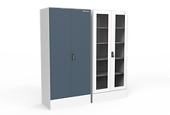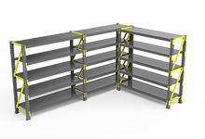

Cupboards and Cabinets Storage and FIFO Racks

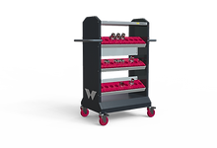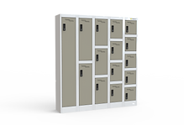

[VMC Tool Adapter Storage Lockers](https://www.wings44.com/bt40adapter-trolley" \t "_self)

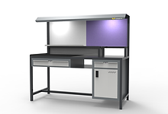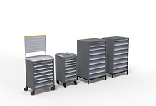

Workstations, Assembly Tables Drawer Cabinets

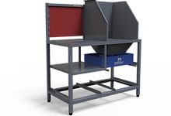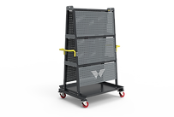

Air Cleaning Tables Perforated Board Tool Trolley

## n

​roducts ofile

**[Home Furniture](https://www.wings44.com/industrial-products" \t "_self)**

[Creative solutions for your home space, built from our proven expertise in furniture design keeping in mind your comfort](https://www.wings44.com/home-products)

[](https://www.wings44.com/home-products)

**[Institutional Furniture](https://www.wings44.com/institutional-products" \t "_self)**

###### [Use your office space efficiently with our wide variety of office furniture, designed ergonomically keeping employees and tasks in mind](https://www.wings44.com/institutional-products)

###### [w2.png](https://www.wings44.com/institutional-products)

## Institutional Furniture

Use your office space efficiently with our wide variety of office furniture, ergonomically designed keeping employees and tasks in mind.

W44_Logo_2.png

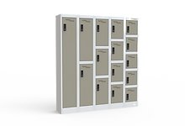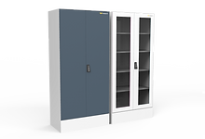  
Cupboards and Cabinets Lockers

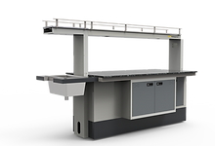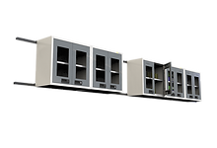

[Laboratory Tables Wall Mounted Cabinets](https://www.wings44.com/laboratory-tables" \t "_self)



Library Shelf Office Furniture

**Company helps clinics and hospitals optimise their functioning**

Over the years, Company have helped greenfield projects in healthcare sector and stand-alone clinics achieve operational efficiency by designing and installing various products ranging from beds (semi-fowler beds, ICU Beds, guest beds) bedside lockers, medicine trolleys, canteen tables, nurse stations, glass cabinets to OT Panelling and OT doors. There team understands the criticality of medical setups and given the ongoing pandemic, They feel blessed to have stood by the medical fraternity and contributed in their own small way to help the community.

**Organization Chart for Budgetary Control**

Chief Executive

Budget Officer

Budget Committee

Production Sales Finance Agreements Personnel Research Manager Manager Manager Manager Manager & Development Manager

**CHAPTER – 4 :**

**DATA ANALYSIS ,**

**PRESENTATION &**

**INTERPRETATION**

**DATA ANALYSIS , PRESENTATION AND INTERPRETATION**

1. **Revenue Expenditure Budget of the Year 2020-21 :**

**(Rs in ‘000)**

|  |  |  |  |  |  |
| --- | --- | --- | --- | --- | --- |
| **Sr. No.** | **Item** | **Budget Estimates** | **Actual** | **Variation (Amount)** | **Variation (Percentage)** |
| 1 | Salaries and Other Establishment | 6231 | 5918.98 | 312.02 | 5% |
| 2 | Operational and Other Expenses | 1100 | 1025 | 75 | 7% |
| 3 | Supplies and Materials | 19421 | 18558.6 | 862.39 | 4% |
| 4 | Minor Works | 1984.1 | 1922.61 | 61.49 | 3% |
| 5 | Interest and Depreciation | 1146.71 | 1100 | 46.71 | 4% |
| 6 | Administrative Expenses | 1009 | 1115 | -106 | -11% |
| 7 | Rent, Rates and Taxes | 156.61 | 180.78 | -24.17 | -15% |
| 8 | Others | 1011 | 854.78 | 156.22 | 15% |
|  | Totals | 32059.42 | 30675.8 | 1383.66 | 4% |

**Interpretation :**

The data pertaining to the generation and consumption have been obtained from the year 2020-21 and represented in above table. The aspect included are total generation in (‘000) and utilization for auxiliary consumption respectively. From the above table and graph we clearly see that all values are decreases but administrative expenses are increases.

1. **Revenue Expenditure Budget of the Year 2021-22 :**

**(Rs in ‘000)**

|  |  |  |  |  |  |
| --- | --- | --- | --- | --- | --- |
| **Sr. No.** | **Item** | **Budget Estimates** | **Actual** | **Variation (Amount)** | **Variation (Percentage)** |
| 1 | Salaries and Other Establishment | 6300 | 6112.5 | 187.5 | 3% |
| 2 | Operational and Other Expenses | 1200 | 1115.52 | 84.48 | 7% |
| 3 | Supplies and Materials | 20000 | 19235 | 765 | 4% |
| 4 | Minor Works | 1990.5 | 2335 | -344.5 | -17% |
| 5 | Interest and Depreciation | 1300.6 | 1364 | -63.4 | -5% |
| 6 | Administrative Expenses | 1450 | 1562 | -112 | -8% |
| 7 | Rent, Rates and Taxes | 500.26 | 600 | -99.74 | -20% |
| 8 | Others | 800 | 926 | -126 | -16% |
|  | Totals | 33541.36 | 33250 | 291.34 | 1% |

**Interpretation :**

The data pertaining to the generation and consumption have been obtained from the year 2021-22 and represented in above table. The aspect included are total generation in (‘000) and utilization for auxiliary consumption respectively.

From the above table and graph we clearly see that all values are decreases but administrative expenses and minor work increases.

1. **Revenue Expenditure Budget of the Year 2022-23 :**

**(Rs in ‘000)**

|  |  |  |  |  |  |
| --- | --- | --- | --- | --- | --- |
| **Sr. No.** | **Item** | **Budget Estimates** | **Actual** | **Variation (Amount)** | **Variation (Percentage)** |
| 1 | Salaries and Other Establishment | 6500 | 6321 | 179 | 3% |
| 2 | Operational and Other Expenses | 1500 | 1365 | 135 | 9% |
| 3 | Supplies and Materials | 22350 | 20365 | 1985 | 9% |
| 4 | Minor Works | 2436 | 2136 | 300 | 12% |
| 5 | Interest and Depreciation | 1236 | 1132 | 104 | 8% |
| 6 | Administrative Expenses | 1356 | 1236 | 120 | 9% |
| 7 | Rent, Rates and Taxes | 365 | 360 | 5 | 1% |
| 8 | Others | 1630 | 1800 | -170 | -10% |
|  | Totals | 37373 | 34715 | 2658 | 7% |

**Interpretation :**

The data pertaining to the generation and consumption have been obtained from the year 2022-23 and represented in above table. The aspect included are total generation in (‘000) and utilization for auxiliary consumption respectively.

From the above table and graph we clearly see that all values are quite similar to their estimated values.

1. **Operational Expenditure Budget for the Year 2020-21 :**

**(Rs in ‘000)**

|  |  |  |  |
| --- | --- | --- | --- |
| **Sr. No** | **Particular** | **Estimated Budget** | **Actual** |
| **1** | **Variable Cost** | 1012 | 899 |
| **2** | **Operative Maintanance** | 756 | 712 |
| **3** | **Finance Charges** |  |  |
|  | Depreciation | 150 | 80 |
|  | Interest on Fixed Capital | 90 | 120 |
|  | **Total of - 3** | **240** | **200** |
|  | **Grand Total (1+2+3)** | **2008** | **1811** |

**Interpretation :**

Observed from the above table the operational expenditure budget of Wings 44 Design and Manufacturing Pvt. Ltd. In the year 2020-21.

Maintenance, employee cost, stationary and general expenses, rebate and share of other expenses is all are fluctuating with the expenses of the year 2020-21. However the total operating maintenance costs are 756 decreasing respectively.

In finance charges depreciation and interest on fixed capital , has been included the total finance charges recording decreasing in the year of 2020-21 respectively.

1. **Operation Budget of the Year 2021-22 :**

**(Rs in ‘000)**

|  |  |  |  |
| --- | --- | --- | --- |
| **Sr. No** | **Particular** | **Estimated Budget** | **Actual** |
| **1** | **Variable Cost** | 1100 | 987 |
| **2** | **Operative Maintanance** | 798 | 744 |
| **3** | **Finance Charges** |  |  |
|  | Depreciation | 160 | 115 |
|  | Interest on Fixed Capital | 100 | 135 |
|  | **Total of - 3** | **260** | **250** |
|  | **Grand Total (1+2+3)** | **2158** | **1981** |

**Interpretation :**

Observed from the above table the operational expenditure budget of Wings 44 Design and Manufacturing Pvt. Ltd. In the year 2021-22.

Maintenance, employee cost, stationary and general expenses, rebate and share of other expenses is all are fluctuating with the expenses of the year 2021-22. However the total operating maintenance costs are 798 decreasing respectively.

The overall budgets results of Wings 44 company is earning more profits because of the increase in the fixed deposits and current accounts in the previous year.

1. **Operational Budget of the Year 2022-23**

**(Rs in ‘000)**

|  |  |  |  |
| --- | --- | --- | --- |
| **Sr. No** | **Particular** | **Estimated Budget** | **Actual** |
| **1** | **Variable Cost** | 1189 | 1089 |
| **2** | **Operative Maintanance** | 821 | 789 |
| **3** | **Finance Charges** |  |  |
|  | Depreciation | 168 | 126 |
|  | Interest on Fixed Capital | 109 | 146 |
|  | **Total of - 3** | **277** | **272** |
|  | **Grand Total (1+2+3)** | **2287** | **2150** |

**Interpretation :**

The overall budgets results of Wings 44 company is earning more profits because of the increase in the fixed deposits in the previous year.

**CHAPTER – 5 :**

**FINDINGS &**

**SUGGESTIONS**

**FINDINGS AND SUGGESTIONS**

1. The variance calculated in revenue budget during the year 2020-21 has decreased by 4% when the actual budget is compared with the estimated budget.
2. The variance calculated in revenue budget during the year 2021-22 has decreased by 1% when the actual budget is compared with the estimated budget.
3. The variance calculated in revenue budget during the year 2022-23 has decreased by 7% when the actual budget is compared with the estimated budget.
4. The calculated in operational expenditure budget during the year 2020-21 has decreased by 197 when actual expenditure budget is compared with estimated expenditure budget.
5. The calculated in operational expenditure budget during the year 2021-22 has decreased by 177 when actual expenditure budget is compared with estimated expenditure budget.
6. The calculated in operational expenditure budget during the year 2022-23 has decreased profit by 137 when actual expenditure budget is compared with estimated expenditure budget.

**SUGGESTIONS**

Planning has become the primary function of management most of the planning relates to individual and individual proposals. Budgets are nothing but the expressions, largely in financial terms. Budgetary control has, therefore become and essential tool of management for controlling and maximizing profits.

1. The company's objectives and how it can be achieved through budgetary control process.
2. Time tables for all stages of budgeting should be followed regularly by all the departments.
3. Reports, statements, forms and other record should be maintained if any information is needed.
4. Continuous comparison of actual performance with budgeted performance will result in knowing whether the company is in profit or loss.

**CONCLUSION**

Every organization has pre-determined set of objectives and goals, but reaching those objectives and goals only by proper planning and executing of the plans economically. WINGS 44 DESIGN AND MANUFACTURING PVT. LTD is objectives of planning promoting and organizing an integrated development of Furniture Company. The organization needs the capable personalities as management to lead the organization successfully, the management makes the plans and implement of these plan are expressed in terms of budget and budgetary control. The Harman International India PVT have budget process in two stages. One is the capital expenditure budget and another is operating maintenance budget, the capital expenditure budget shows the list of capital projects selected for investment along with their estimated cost, operating & maintenance budget refers to the repairs & maintenance budgets, the special budgets are rarely used in the organization like long-term budgets, research & development budget and budget for consultancy.

**BIBOLOGRAPHY**

Financial Statements of the Company

Accounting and Finance for Managers

**Websites:**

<https://www.wings44.com>

<https://core.ac.uk>

<https://ijarlie.com>

http://data.conferenceworld.in

Bottom of Form